BLOGPOST - A Technical Due Diligence Framework for Early Stage Startups

A Technical Due Diligence Framework for Early Stage Startups



Early stage investors face 3 main risks when they assess a startup investment:
(a) Market. Can MONEY be made?
(b) Competition. Can they WIN?
(c) Execution. Can the FOUNDERS DELIVER?
For (a) and (b), we research the competition and do reference calls with early customers.
But the execution risk is also a hard one to understand, because it’s driven by the team. And, you know, people are pretty unpredictable ;-)
It’s the founder’s task to deliver in plenty of domains including, but not limited to, hiring and team management, sales and marketing, fundraising, etc.

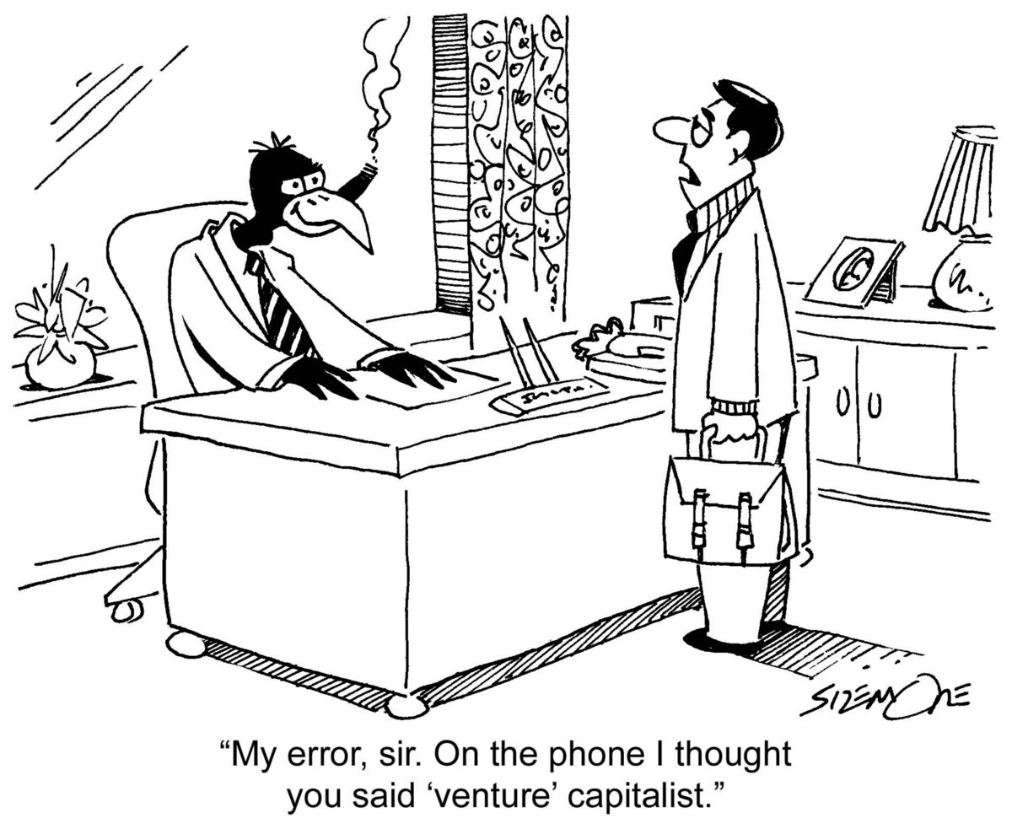

Particularly, at the stage we invest at Point Nine Capital, the responsibilities of the tech and product team are:
To iterate fast to meet the customer needs on time (speed of development)
To deliver a product that works at the scale needed (reliability)
At the stage we invest, we don’t expect companies to be perfect, but we need to figure out what level of technical execution risk we face. Lately, we have been working on a more standard technical due diligence process to understand that — which we run in a 1 hour call with the tech founder.
By having a more standard process, we hope to:
Grasp better those risks.
Decide faster about new investments (“good VCs don’t waste founder’s time”).
Help the founders understand some of the challenges to come — “unknown unknowns” — so they can figure out how to address them.
We are aware that we don’t have a perfect process.
Now, we want to share it with the community to get feedback and to try to make it more helpful for everyone involved.

A guideline — Assessment, Learning and Teaching

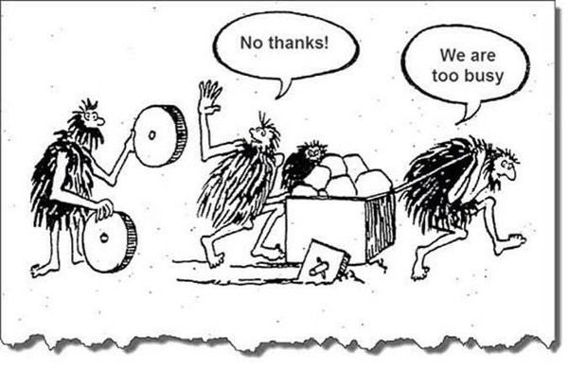

Technical debt in one image source
Unfortunately, there’s no great framework to understand how great tech founders become world-class CTOs. There’s a great article about technical due diligence for startups, which inspired big chunks of our process, but we think it doesn’t cover some of the softer skills/personal aspects of becoming a tech leader in a startup.
Thus, we adapted some concepts from the assessment, learning and teaching cycle to frame relevant questions under a guideline:
(a) How the product has been built (assessment),
(b) The ability of the team to learn fast and iterate quickly (learning)
(c) Their ability to work together and get the best out of every team member (teaching)

Assessment
During the first part of the call, we try to understand:
How the product has been built until TODAY
If it will work TOMORROW when success brings trouble. No trouble, no success ;-)
As mentioned, we don’t expect everything to be perfect.

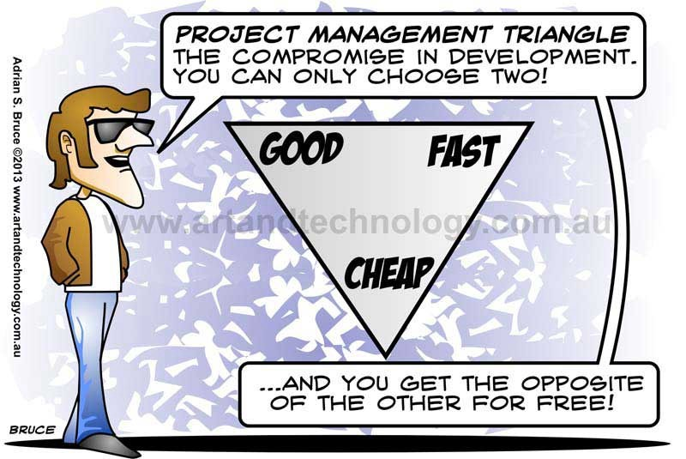

No need to state the source… ;-)
Rather, we try to understand where your product is today, how you’ve built it and what kind of compromises you chose.
There’s no formula for that — most of the due diligence is an art, rather than a science! But as early stage investors we have a privilege: founders teach us how they built their products. Thanks to that, we can develop a sense of what’s achievable with the limited resources of a company at stage.
Also different business models have different requirements — ie. scalability might be more critical for an infrastructure startup than an eCommerce one. What we are interested in is how the team makes decisions in front of trade-offs:
(a) Code ownership: inhouse vs oursourcing
(b) Agility: speed vs reliability
(c) Monitoring: understanding all vs little
(d) Compliance and Security: risks

Learning
It goes without saying, but just in case: a startup is a fast moving and changing environment.
In almost all scenarios, the winner is the one that iterates the fastest. First to find product market fit and then to keep evolving fast to win over competition.
That’s why in the second part of the call we focus on what determines product development speed:
(a) Intellectual curiosity and Thoughtfulness: awareness of the challenges to come is the first step to be ready to solve them in the future
(b) Processes and Tools: should be in place to achieve high productivity
(c) Organization: should be defined to avoid friction and align goals

Teaching
To some geeks, it might sound BS to speak about management skills, but you know what? People like to work with great technical talents AND nice people ;-)

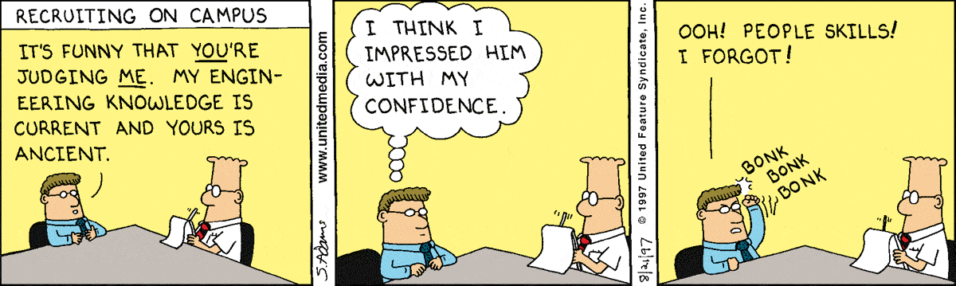
by Dilbert
The tech founder of a company is the one who does the first hires. And the first engineers will set the bar and the tone for the next ones. All together, they will give birth to their leadership style and engineering culture.
Caveat: we know there are great technologists who don’t want to (or can’t) deal with hiring and managing people. They can be a good technical founder if they are the only person gifted enough to build that product. In that case, they need a great VP of Engineering ASAP.
With this exception, we like tech founders who are also good at people management:
(a) Leadership: teaching by example and communication
(b) Hiring: attracting great talents
(c) Managing: motivating and keeping those talents
(Bonus) Point Nine’s Early Stage Startup Tech Due Diligence Calculator

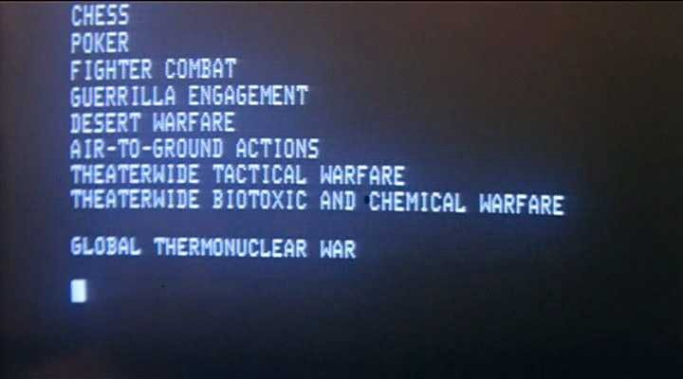

Are you sure you want to play?
As mentioned before, for Point Nine’s investment process, the technical due diligence is a conversation with the tech founder.
The previous sections are a guideline for that discussion.
But as a toy project, we have turned all those questions into a typeform calculator.

Do you have another 5 min to waste?
Ready to check how would you do at Point Nine’s tech due diligence?

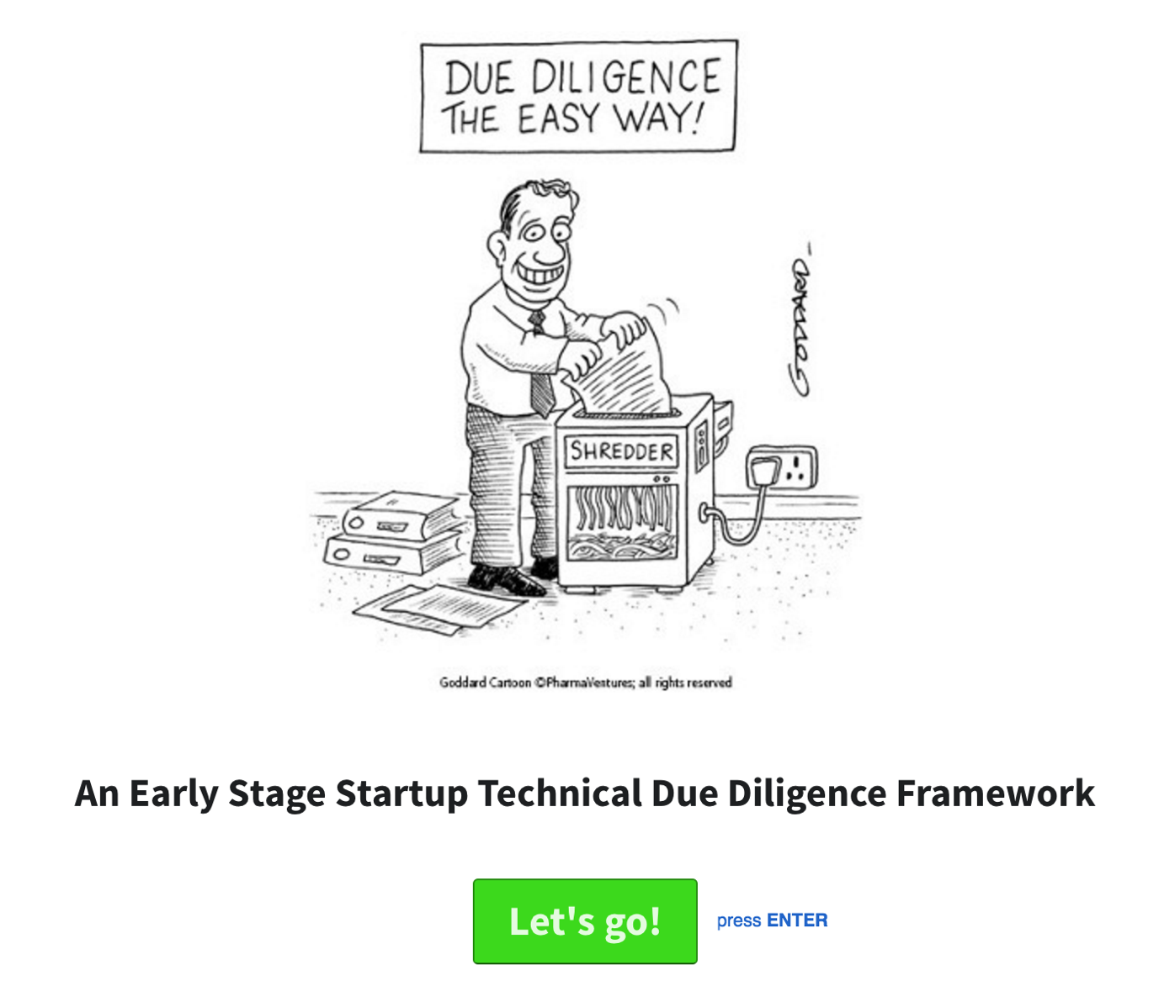

Aus <https://medium.com/point-nine-news/a-technical-due-diligence-framework-for-early-stage-startups-c24d5408256e#.9q7ekz356>

